SSS Design Document

**Overview:**

In SSS, a secret key for any system is secured by transforming that key into multiple shared keys. Each key belongs to a different user, to get past this security; a minimum number of shared keys should be used. In this case there are 4 shares of the secret key but the required number of minimum shares is 2. This means even though there are 4 shares of the secret key, the locker can be accessed by 2 users since the minimum number of required shares are 2.

**Sequence Diagram:**

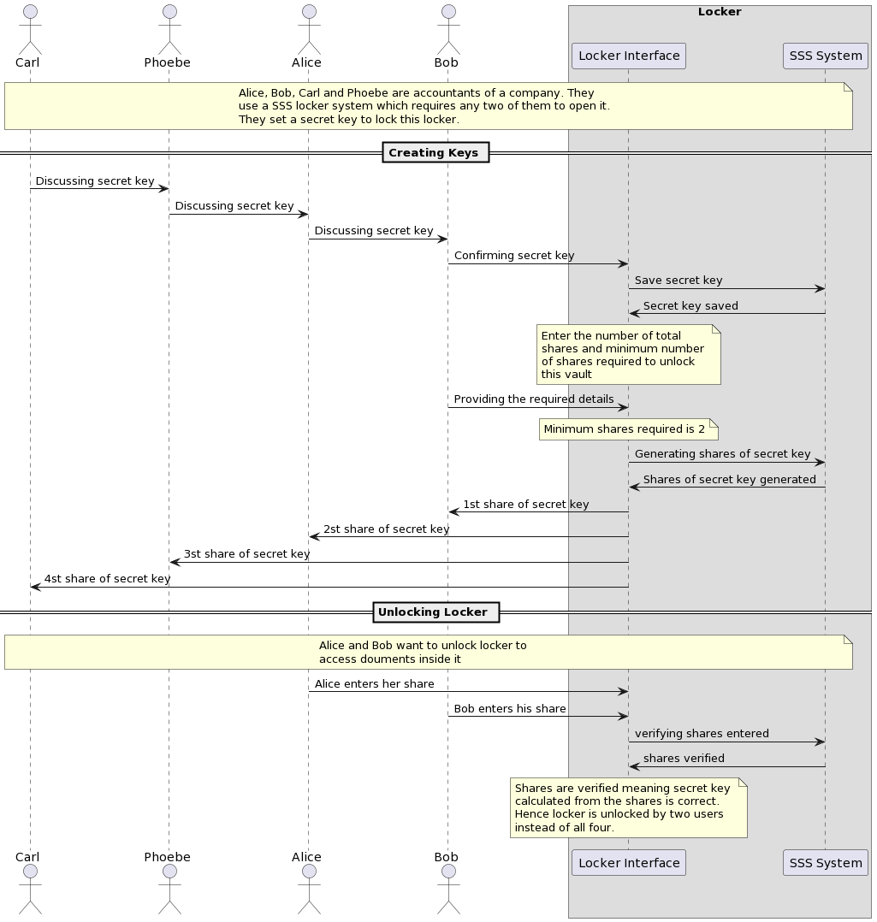

**Class Diagram:**

